Report by: 1409046  
Role: Level Design & Artist liaison

Game Version: Latest – with Menus  
Date Reported: 15/04/2016

QA Status: Passed

Severity: Severe

Priority: High

Test Introduction:

This test was to check the movement script was working correctly with the model the artists gave us. To test this, I attached the pre-written script to the model and pressed play from within the scene in unity.

Expected outcome:

I expected the model to run along the track smoothly from start to finish, tilting to the side when moving left and right and increasing speed as the time went on.

Actual outcome:

When the game loaded the model was rocking back and forward as it moved down the track.

Screenshot of the bug:

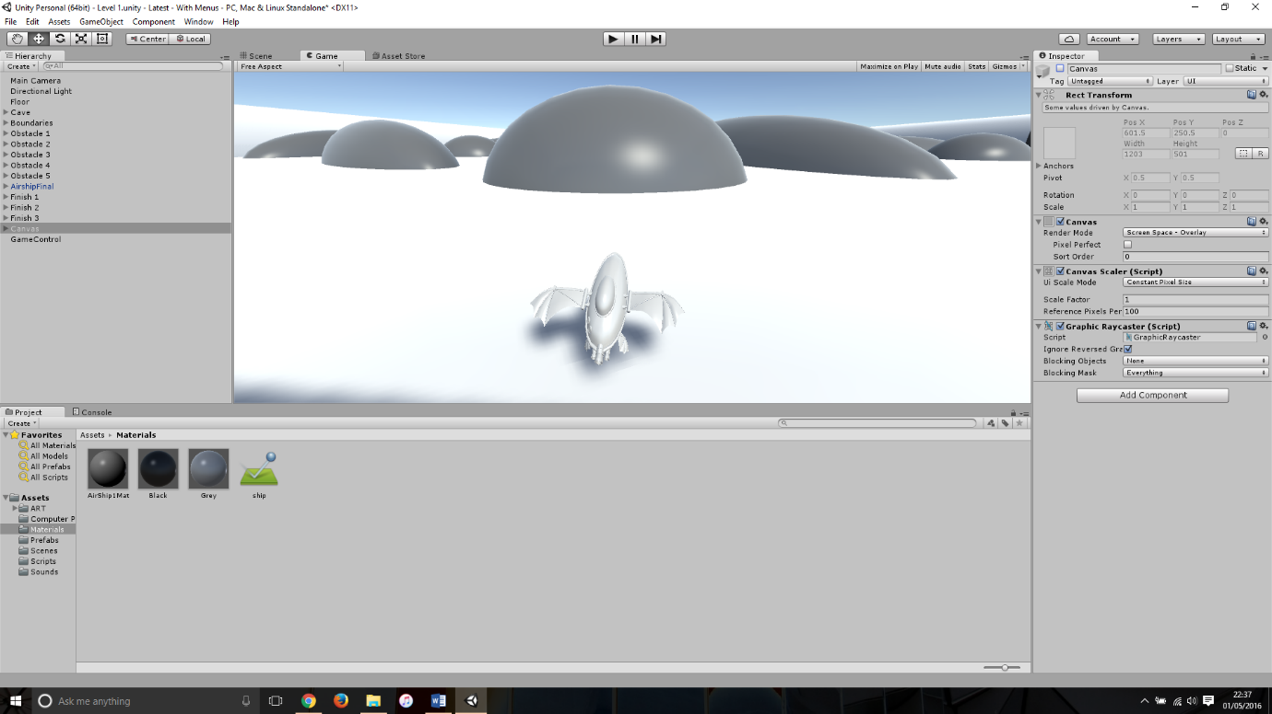

Potential cause:

A potential cause for this bug would be the shape of the collider attached to the model, as we used a mesh collider at first the shape of the ship made the movement ‘jaggedy’.

Another cause could be a problem with the movement script as it had only been tested on a flat box before.

Suggested Fix:

To fix this bug I first removed the mesh collider that was attached to the model, I then attached a box collider to the base of the model and another box collider attached on top of the base collider to simulate the wingspan.